KIDS project

# Dataset

Cases of pediatric trauma in the KID database from

* 2006, 2009, 2012, identified using International Classification of Disease, Ninth Revision, Clinical Modification (ICD-9CM) codes
* 2016, 2019 ICD-10CM codes

Preprocessed by Lakshika

# Frequency Table

Steps:

* Looking at only pediatric patients by choosing only age<18 cases.
* Looking at only trauma patients by choosing only event_anydx_traumaICD9/10 = 1 cases.
* Adjust total cost:
  + 2006, 2009, 2012:
  + Adjust using CPI to 2021 prices
    - totcost * 1.292034
    - totcost * 1.214122
    - totcost * 1.134498
  + 2016, 2019
    - Adjust using code gen total_COST= CCR_KID*TOTCHG adjust CPI, too
* For Child abuse:
  + 2006, 2009, 2012
    - Already preprocessed Child_abuse column
  + 2016, 2019
    - Define Child_abuse by checking either one of below is true
      * 'Child_neglect_SUS'
      * 'Child_neglect_CON'
      * 'Child_psychoabuse_SUS'
      * 'Child_psychoabuse_CON'
      * 'Child_physicalabuse_SUS'
      * 'Child_physicalabuse_CON'
      * 'encounter_childabuse'
      * 'Child_sexual_abuseSUS'
      * 'Child_sexual_abuseCON'
      * 'Encounter_rape'
      * 'child_maltreatmentCON'
      * 'Shaken_infant'

Old dataset: 2006, 2009, 2012

Non-SCAN 411, 620 SCAN 8, 185 total: 419, 805

New total dataset: 2006, 2009, 2012，2016, 2019

Non-SCAN 650, 358 SCAN 18, 242 total:668, 600

Changes for new dataset:

1. There’s no total cost column “totcost” for the new data, but there is a “TOTCHG” column in the new dataset, which seems to be the total cost, but not sure about the description or unit of that.

TOTCHG * RRC_KID

2. There’s no “Child_abuse” column for the new data, but has several related columns:

【"Child_neglect_SUS" "Child_neglect_CON"

"Child_psychoabuse_SUS" "Child_psychoabuse_CON" 】

"Child_physicalabuse_SUS" "Child_physicalabuse_CON"

"encounter_childabuse" "Child_sexual_abuseSUS"

"Child_sexual_abuseCON" "Encounter_rape"

"child_maltreatmentCON" "shaken_infant"

【"Encounter_MH” 】

which I also need to check in detail about the meaning. Do we need to take all the columns included in child abuse?

Use all of them sus.

3. There is no “atype” column for the new data, which is admission type, I will need to check if there exists the corresponding column after given the data dictionary.

Ask lashika to send admit type data.

Leave out atype.

4. There is no “nachtype” (hospital type, nach designation), no “hosp_control” in the new data.

Leave out nachtype

Ask lashika to send nachtype data.

Hosp_control - h_ctrl

5. There is no “event_primdx_traumaICD9” and no “event_anydx_traumaICD9” in the new data, but has “event_primary_traumaICD10” and “event_anydx_traumaICD10”

Instead.

Replace them

Xiss niss

XISS RISS

Results:

Old data:

<https://outlook.office.com/mail/deeplink?AttachmentId=AQMkAGMyNzgzMjVlLWY2Y2YtNDAyYS1iNWU0LWM0NjFiNTZmOWI0ZQBGAAADjbYnTWjMGkmCJD893fFdTgcAMW%2BOuiXQ80O7KkYHm12XUwAAAgEMAAAAMW%2BOuiXQ80O7KkYHm12XUwABrP3hnAAAAAESABAAyslWDIYra0GaFLoR5Z%2BHew%3D%3D&ItemId=AQMkAGMyNzgzMjVlLWY2Y2YtNDAyYS1iNWU0LWM0NjFiNTZmOWI0ZQBGAAADjbYnTWjMGkmCJD893fFdTgcAMW%2BOuiXQ80O7KkYHm12XUwAAAgEMAAAAMW%2BOuiXQ80O7KkYHm12XUwABrP3hnAAAAA%3D%3D&AttachmentName=Results-6.xlsx>

New data:

<https://stanfordmedicine.app.box.com/file/915905893727>

New data deleted the Asian, Native American, Others race group

<https://stanfordmedicine.app.box.com/file/915905893727>

Table1: For all trauma patient cases, compare SCAN and Non-SCAN patients with variables below:

Patient demographic characteristics categorization included:

* Race: 6 groups including White, Black, Hispanic, Asian or pacific islander, Native American, and Other
* Gender: 2 groups including males and females
* Age: 5 groups including <1, 1-3, 4-7, 8-11, and 12-17 years old.
* SES: 4 groups based on Zip Code associated median household income

The Injury Severity Score (ISS) was calculated based on ICD9-CM and ICD10-CM codes. ISS characteristic categorization included:

* ISS: 3 groups including mild/moderate (1-15), serious (16-24), and severe (>25)

Hospitalization characteristics categorizations included:

* Primary payer: 4 groups including Medicaid, Private, Self-pay, and Other
* Hospital location: 3 groups including Rural, Urban nonteaching, Urban teaching
* Hospital Bed-size: 3 groups including small, medium, and large
* Hospital region: 4 groups including Northeast, Midwest, South, and West
* Hospital type: 3 groups including Not children’s, Children’s general, and Children’s unit of general hospitals (no information for new data)

Also, hospital length of stay (LOS), mortality, and hospital cost was compared between SCAN and Non-SCAN patients, and among different ethnicities of SCAN patients.

Table2: For SCAN patient cases, compare how different races perform in different factors.

# Regression Analysis:

All for old data, will redo the analysis once confirmed the new data column definition

1. Methods:
   * Using R svyglm function, Survey-weighted generalised linear models.
   * Fit a generalised linear model to data from a complex survey design, with inverse-probability weighting and design-based standard errors.
   * Linear if outcome is continuous, Logistic if outcome is categorical.
2. Experiments:

## For Child abuse ~ Race:

Y ~ X1, X2, X3

* + - Formula: Child_abuse_indicator ~ RACE
    - Family: binomial regression, a regression analysis technique in which the response (often referred to as Y) has a binomial distribution.
    - Data: All trauma patient data
    - Results:

R-regression Table 1

Abuse/Race: (unadjusted)

| Race | OR (95% CI) | P value |
| --- | --- | --- |
| White | Reference | - |
| Black | 1.86 (1.72-2.01) | P<0.01 |
| Hispanic | 1.2 (1.11-1.3) | P<0.01 |
| Asian or pacific islander | 0.57 (0.43-0.76) | P<0.01 |
| Native American | 1.26 (0.95-1.68) | P: 0.1 |
| Other | 1.51 (1.33-1.71) | P<0.01 |

## For Child abuse ~ all characteristics

Y ~ X1, X2, X3

* + - Child_abuse_indicator ~ RACE + SEX + AGEGROUP + PAYER + ZIPINC_QRTL+ HOSP_LOCTEACH + HOSP_BEDSIZE + HOSP_REGION + NACHTYPE
    - Family: binomial regression, a regression analysis technique in which the response (often referred to as Y) has a binomial distribution.
    - Data: All trauma patient data
    - Results:
  + Add ISS

Abuse, Adjusted for Race, sex, age group, Payer, Zip code, Hospital location, hospital bed size, hospital region, hospital control, hospital type

Race is independent predictor of Child abuse despite controlling for SES

R-regression Table 2

|  | OR (95% CI) | P value |
| --- | --- | --- |
| Race |  |  |
| White | Reference | - |
| Black | 1.2 (1.06-1.35) | P<0.01 |
| Hispanic | 0.61 (0.54-0.7) | P<0.01 |
| Asian or pacific islander | 0.50 (0.33-0.74) | P<0.01 |
| Native American | 0.71 (0.43-1.17) | P: 0.18 |
| Other | 0.85 (0.71-1.01) | P: 0.07 |
| Age |  |  |
| 12-17 | Reference | - |
| 8-11 | 1.12 (0.73-1.72) | P: 0.58 |
| 4-7 | 3.07 (2.29-4.12) | P<0.01 |
| 1-3 | 19.7 (15.6-24.8) | P<0.01 |
| <1 | 90.25 (72.2-112.7) | P<0.01 |
| Gender |  |  |
| Male | Reference | - |
| Female | 1.09 (1.00-1.2) | P: 0.04 |
| Payer |  |  |
| Medicaid | Reference | - |
| Private | 0.31 (0.28-0.36) | P<0.01 |
| Self-pay | 0.51 (0.39-0.67) | P<0.01 |
| Other | 0.95 (0.78-1.16) | P: 0.65 |
| Zip code |  |  |
| 4 | Reference | - |
| 3 | 1.43 (1.22-1.68) | P<0.01 |
| 2 | 1.40 (1.19-1.63) | P<0.01 |
| 1 | 1.33 (1.13-1.55) | P<0.01 |
| Hospital location |  |  |
| Rural | Reference | - |
| Urban nonteaching | 0.83 (0.61-1.13) | P: 0.25 |
| Urban teaching | 1.22 (0.9-1.65) | P: 0.18 |
| Hospital Bed-size |  |  |
| small | Reference | - |
| Medium | 1.11 (0.95-1.29) | P: 0.16 |
| large | 1.29 (1.08-1.54) | P<0.01 |
| Hospital region |  |  |
| Northeast | Reference | - |
| Midwest | 1.54 (1.34-1.78) | P<0.01 |
| South | 0.84 (0.73-0.96) | P: 0.01 |
| West | 0.89 (0.77-1.03) | P: 0.14 |
| Hospital Type |  |  |
| Not children’s | Reference | - |
| Children’s general | 3.31 (2.86-3.83) | P<0.01 |
| Children’s specialty | 3.51 (1.01-12.2) | P: 0.04 |
| Children’s unit of general | 1.47 (1.27-1.69) | P<0.01 |

## For Mortality ~ all other characteristics - All data

* + - DIED ~ SEVGROUP + RACE + SEX + AGEGROUP + PAYER + ZIPINC_QRTL + HOSP_LOCTEACH + HOSP_BEDSIZE + HOSP_REGION + NACHTYPE
    - Family: binomial regression, a regression analysis technique in which the response (often referred to as Y) has a binomial distribution.
    - Data: All trauma patient data

## For Mortality ~ all other characteristics - only SCAN data

* + - DIED ~ SEVGROUP + RACE + SEX + AGEGROUP + PAYER + ZIPINC_QRTL + HOSP_LOCTEACH + HOSP_BEDSIZE + HOSP_REGION + NACHTYPE
    - Family: binomial regression, a regression analysis technique in which the response (often referred to as Y) has a binomial distribution.
    - Data: only SCAN data

## For Mortality ~ all other characteristics - only Non-SCAN data

* + - DIED ~ SEVGROUP + RACE + SEX + AGEGROUP + PAYER + ZIPINC_QRTL + HOSP_LOCTEACH + HOSP_BEDSIZE + HOSP_REGION + NACHTYPE
    - Family: binomial regression, a regression analysis technique in which the response (often referred to as Y) has a binomial distribution.
    - Data: only Non-SCAN data

Comparison Results:

SCAN vs. Non-SCAN patients hospital mortality adjusted for Race, sex, age group, ISS, Payer, Zip code, Hospital location, hospital bed size, hospital region, hospital control, hospital type (SCAN not very concise)

When controlled for SES injury and hospital type, Race is not a predictor of mortality.

| Non-SCAN Adjusted Mortality | | | SCAN Adjusted Mortality | | |
| --- | --- | --- | --- | --- | --- |
|  | OR (95% CI) | P value |  | OR (95% CI) | P value |
| ISS |  |  |  |  |  |
| ISS >25 | Reference | - | ISS >25 | Reference | - |
| ISS 16-24 | 0.18 (0.15-0.2) | P<0.01 | ISS 16-24 | 0.17 (0.11-0.26) | P<0.01 |
| ISS 0-15 | 0.02 (0.02-0.02) | P<0.01 | ISS 0-15 | 0.1 (0.07-0.16) | P<0.01 |
| Race |  |  | Race |  |  |
| White | Reference | - | White | Reference | - |
| Black | 1.2 (1.02-1.4) | P: 0.02 | Black | 1.3 (0.85-2.03) | P: 0.2 |
| Hispanic | 1.09 (0.93-1.28) | P: 0.2 | Hispanic | 1.09 (0.67-1.7) | P: 0.7 |
| Asian or PI | 1.26 (0.85-1.86) | P: 0.24 | Asian or PI | 0.67 (0.1-4.51) | P: 0.6 |
| Native American | 0.7 (0.37-1.43) | P: 0.37 | Native American | 0.7 (0.09-5.5) | P: 0.7 |
| Other | 1.35 (1.06-1.7) | P: 0.01 | Other | 2 (1.15-3.89) | P:0.01 |
| Age |  |  | Age |  |  |
| 12-17 | Reference | - | 12-17 | Reference | - |
| 8-11 | 0.68 (0.55-0.85) | P<0.01 | 8-11 | 0 (0) | P<0.01 |
| 4-7 | 0.9 (0.74-1.08) | P: 0.27 | 4-7 | 2.79 (0.77-1) | P: 0.1 |
| 1-3 | 1.4 (1.17-1.67) | P<0.01 | 1-3 | 1.97 (0.63-6.1) | P: 0.2 |
| <1 | 2.3 (1.9-2.8) | P<0.01 | <1 | 1.02 (0.32-3.2) | P: 0.9 |
| Gender |  |  | Gender |  |  |
| Male | Reference | - | Male | Reference | - |
| Female | 1.08 (0.96-1.22) | P: 0.16 | Female | 1.19 (0.85-1.67) | P: 0.2 |
| Payer |  |  | Payer |  |  |
| Medicaid | Reference | - | Medicaid | Reference | - |
| Private | 0.89 (0.78-1.02) | P: 0.09 | Private | 1.44 (0.92-2.25) | P: 0.1 |
| Self-pay | 1.93 (1.58-2.35) | P<0.01 | Self-pay | 1.98 (0.79-4.97) | P: 0.1 |
| Other | 1.54 (1.24-1.91) | P<0.01 | Other | 4.41 (2.68-7.25) | P<0.01 |
| Zip code |  |  | Zip code |  |  |
| 4 | Reference | - | 4 | Reference | - |
| 3 | 1.1 (0.92-1.33) | P: 0.26 | 3 | 0.65 (0.36-1.18) | P: 0.1 |
| 2 | 1.39 (1.17-1.66) | P<0.01 | 2 | 0.75 (0.42-1.34) | P: 0.3 |
| 1 | 1.23 (1.03-1.47) | P: 0.02 | 1 | 0.93 (0.54-1.59) | P: 0.7 |
| Hospital location |  |  | Hospital location |  |  |
| Rural | Reference | - | Rural | Reference | - |
| Urban nonteaching | 2.72(1.54-4.81) | P<0.01 | Urban nonteaching | 3.45 (0.38-30) | P: 0.2 |
| Urban teaching | 4.28 (2.45-7.48) | P<0.01 | Urban teaching | 2.16 (0.15-30) | P: 0.5 |
| Hospital Bed-size |  |  | Hospital Bed-size |  |  |
| small | Reference | - | small | Reference | - |
| Medium | 1.27 (0.98-1.65) | P: 0.06 | Medium | 1.46 (0.8-2.5) | P: 0.1 |
| large | 1.5 (1.15-1.95) | P<0.01 | large | 0.82 (0.4-1.58) | P: 0.5 |
| Hospital region |  |  | Hospital region |  |  |
| Northeast | Reference | - | Northeast | Reference | - |
| Midwest | 1.54 (1.25-1.89) | P<0.01 | Midwest | 2.05 (1-3.8) | P: 0.02 |
| South | 1.57 (1.31-1.87) | P<0.01 | South | 2.73 (1.5-4.8) | P<0.01 |
| West | 1.41 (1.17-1.71) | P<0.01 | West | 1.75 (0.9-3.3) | P: 0.08 |
| Hospital Type |  |  | Hospital Type |  |  |
| Not children’s | Reference | - | Not children’s | Reference | - |
| Children’s general | 1.05 (0.87-1.26) | P: 0.6 | Children’s general | 1.11 (0.6-2.03) | P: 0.7 |
| Children’s specialty | 0 (0) | P<0.01 | Children’s specialty | 0 (0) | P<0.01 |
| Children’s unit of general | 1.05 (0.9-1.2) | P: 0.44 | Children’s unit of general | 1.52 (0.8-2.7) | P: 0.1 |

# 4. Two Sample Analysis:

Dunnetts test, keep race as a variable, control ISS, take LOS as measurement, we want to check how race affects Length of Stay in each of SCAN or Non-SCAN cases, while controlling ISS to specific levels.

1. Length of Stay ~ ISS > 25, Non-SCAN
2. Length of Stay ~ ISS 16-24, Non-SCAN
3. Length of Stay ~ ISS 0-15, Non-SCAN
4. Length of Stay ~ ISS >25, SCAN
5. Length of Stay ~ ISS 16-24, SCAN
6. Length of Stay ~ ISS 0-15, SCAN

Overall black people have longer LOS regardless of mechanism

For ISS moderate and mild, among black SCAN patients, the average excess LOS is almost doubled compared to the average excess LOS among black Non-SCAN patients.

LOS original days range, ISS > 25 fluctuate, ISS moderate and mild ranges are narrow.

3 by 2

Severe Moderate Mild x SCAN Non-SCAN

Results:

1. Length of Stay ~ ISS > 25, Non-SCAN

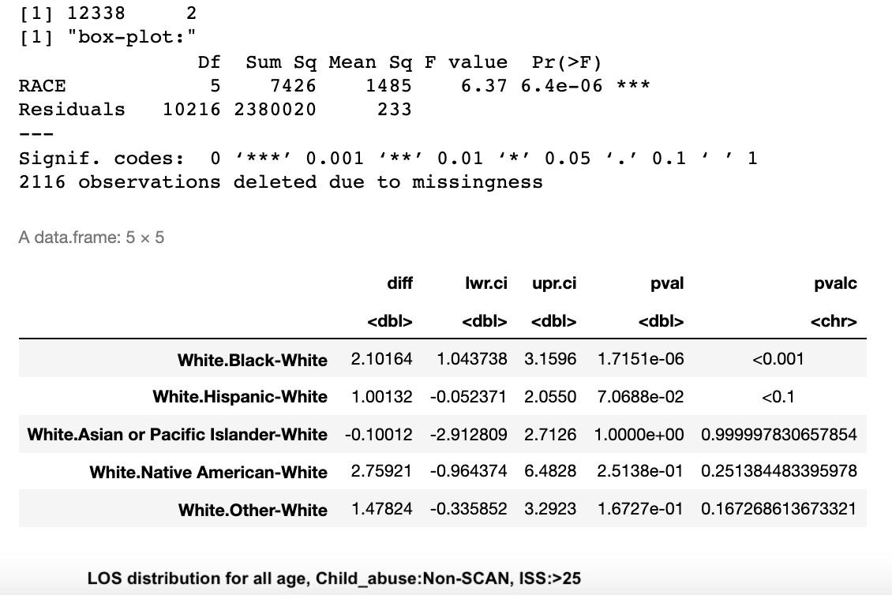

1. Length of Stay ~ ISS 16-24, Non-SCAN

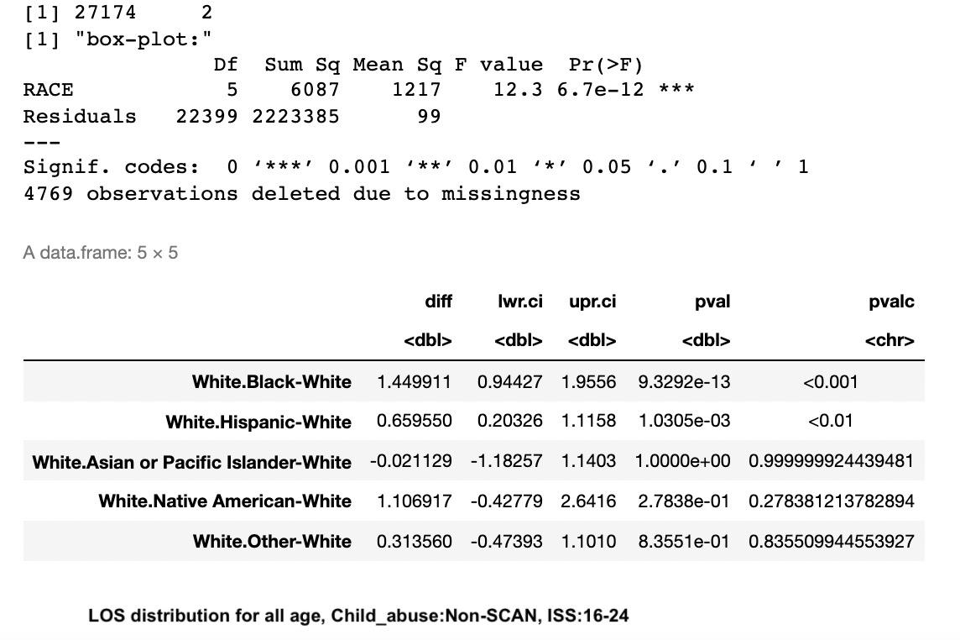

1. Length of Stay ~ ISS 0-15, Non-SCAN

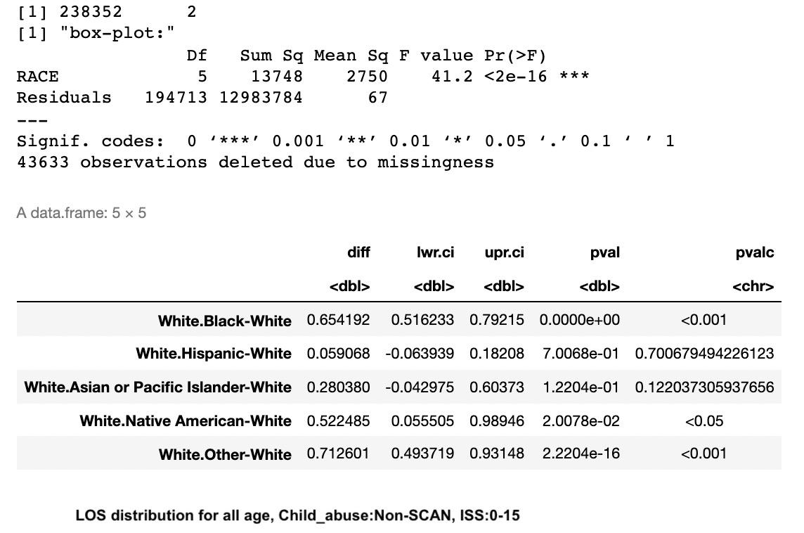

1. Length of Stay ~ ISS >25, SCAN

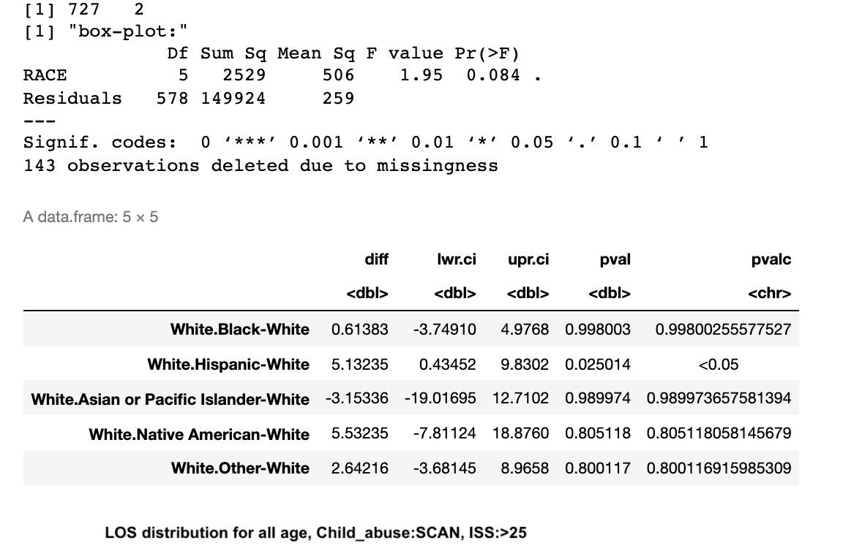

1. Length of Stay ~ ISS 16-24, SCAN

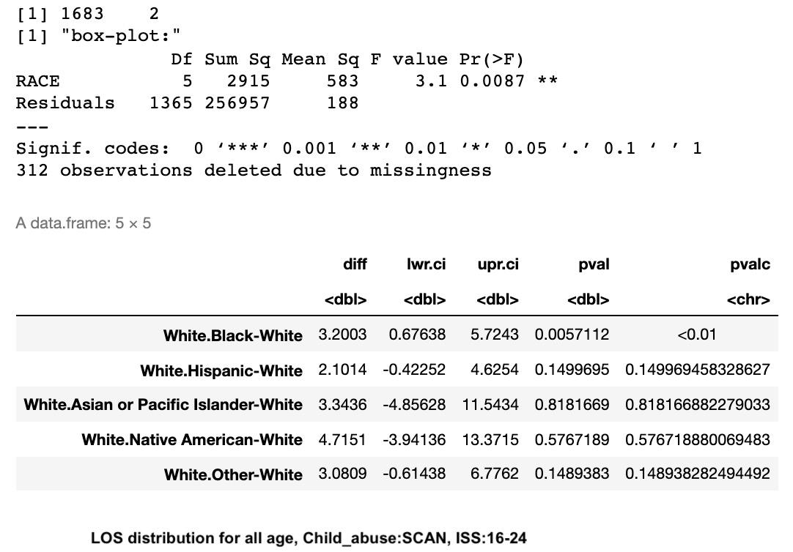

1. Length of Stay ~ ISS 0-15, SCAN

